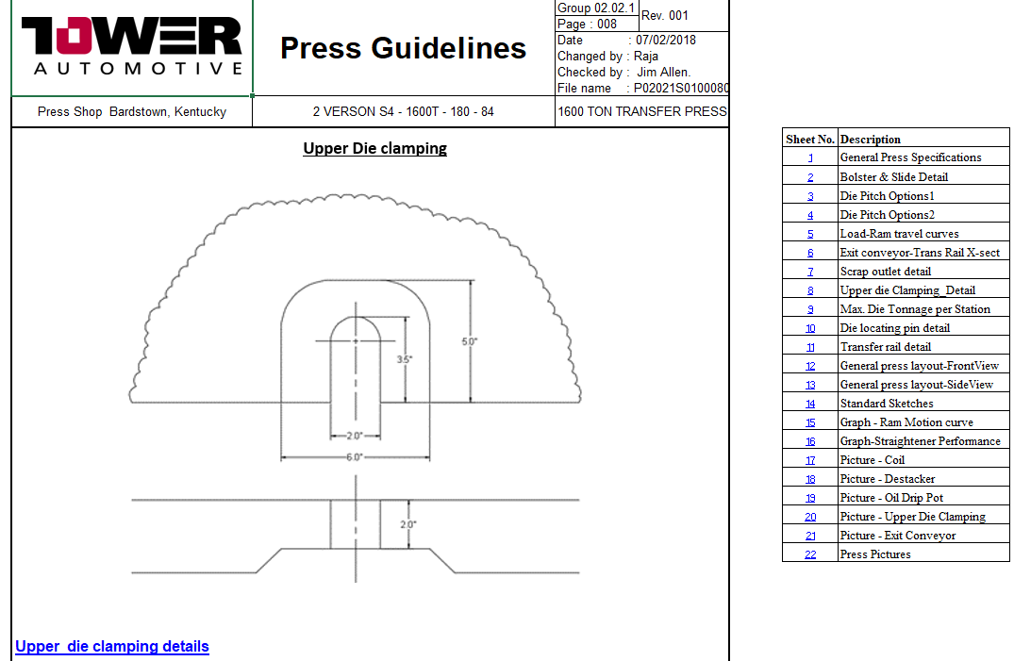
SharePoint – Presses – Tower Automotive – Press Documents – Bardstown – 02-1600Ton

